Project Idea

This document describes the current design idea of our text visualization project. The images are just used to show our idea briefly, not the snapshots for implemented project. Here we use New York Times news in Austin, 2002 as an example.

As text stream arriving, clusters are formed and changed based on their keyword relevancy. First, a stream graph is used to show a brief information about clusters in each time period. It is a static graph summarizing the remarkable topics changing in the whole data set.

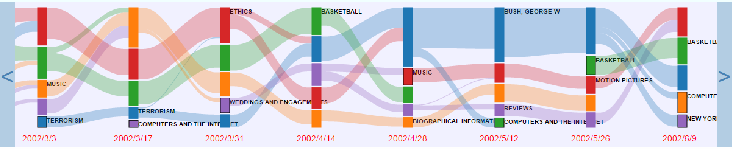

A selection method is provided to choose and play part of the stream graph for details. The selection unit is one cluster in a curtain time period.

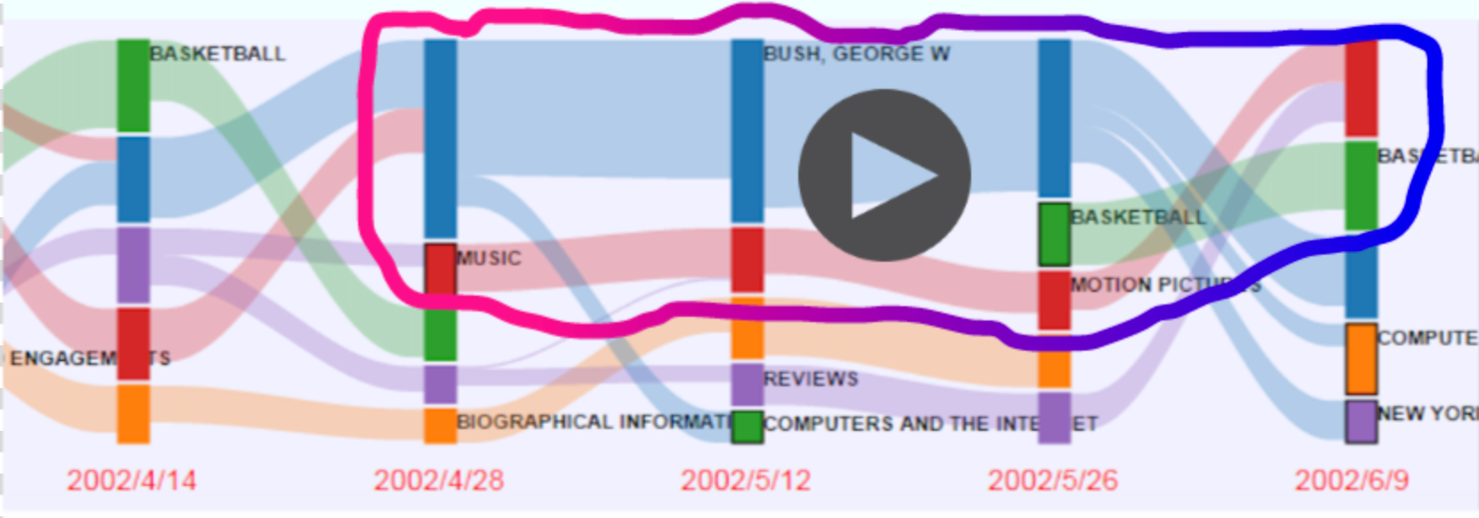

We will use an animated force directed graph to show the changing process of the selected clusters. We will be focusing on the animation display in the future.

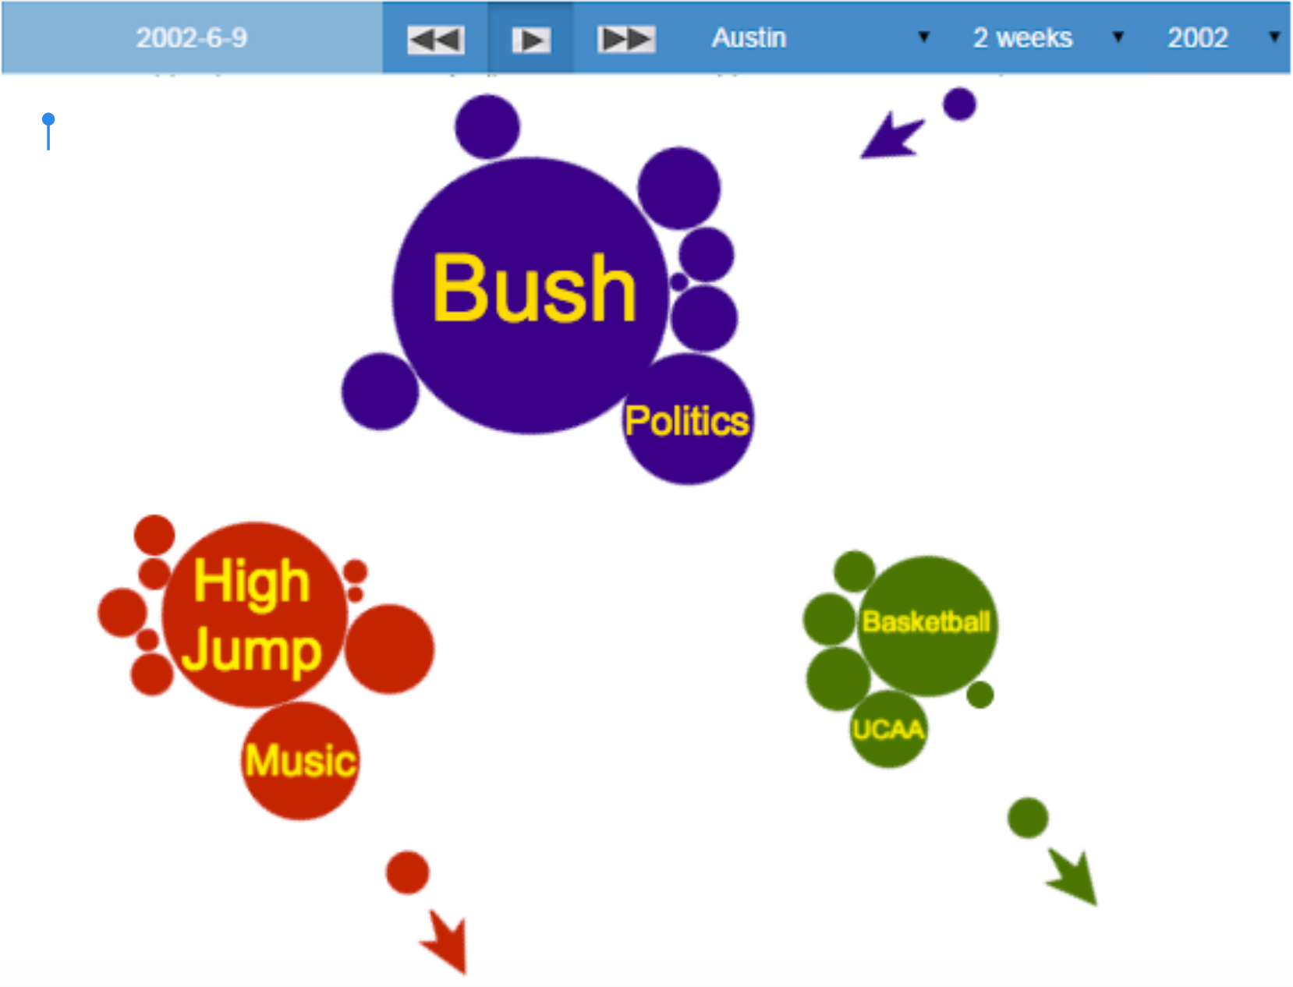

Some basic interaction will be added to dig inside the details of each cluster, keywords or news.

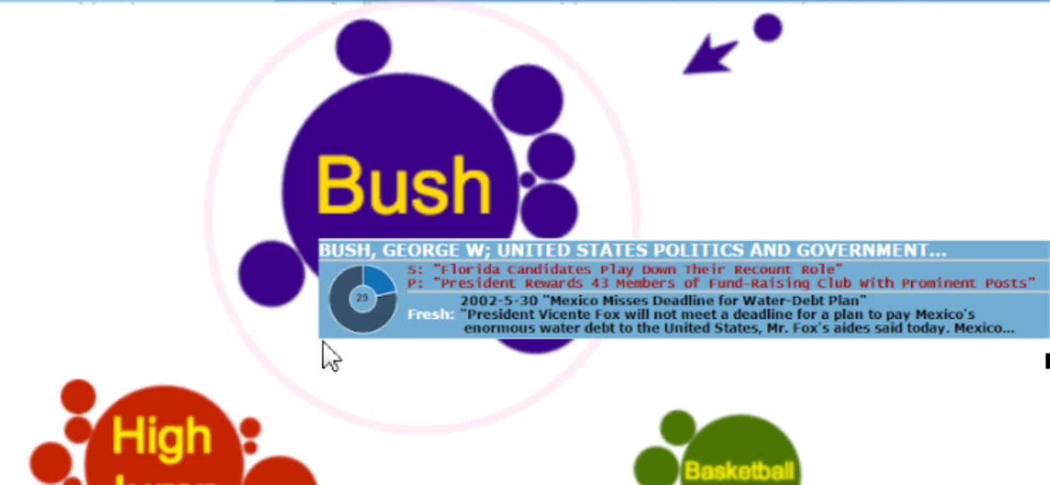

By clicking inside one cluster, more detailed information will display.

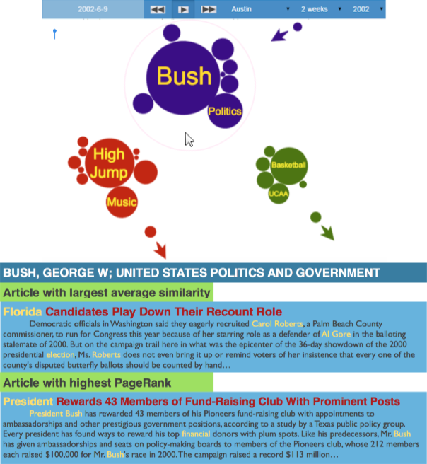

Some statistic graphs will also be used in the system to give an intuitive feeling of the dataset.